**Symbiosis School, Nasik.**

**Std: X Term I (2020-21)**

**Subject: English Language & Literature - Worksheet – 42**

**Lesson : Chapter 11 – The Proposal By Anton Chekov**

**About the Author**

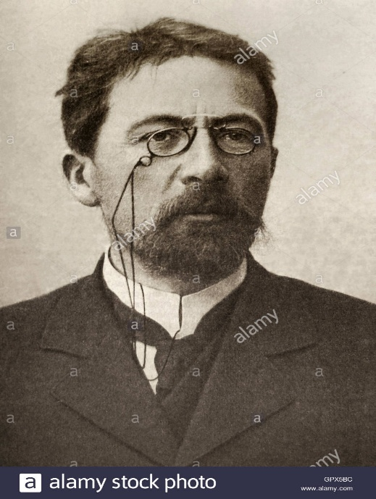

**Anton Chekhov**, in full **Anton Pavlovich Chekhov**, (born January 29 [January 17, Old Style], 1860, [Taganrog](https://www.britannica.com/place/Taganrog), Russia—died July 14/15 [July 1/2], 1904, Badenweiler, Germany), Russian playwright and master of the modern [short story](https://www.britannica.com/art/short-story). He was a literary artist of [laconic](https://www.merriam-webster.com/dictionary/laconic) precision who probed below the surface of life, laying bare the secret motives of his characters. Chekhov’s best [plays](https://www.britannica.com/art/dramatic-literature) and short stories lack complex plots and neat solutions. Concentrating on apparent trivia lities, they create a special kind of atmosphere, sometimes termed haunting or lyrical. Chekhov described the Russian life of his time using a deceptively simple technique devoid of obtrusive literary devices, and he is regarded as the outstanding representative of the late 19th-century Russian [realist](https://www.britannica.com/topic/realism-philosophy) school.

### The Proposal Introduction

The Proposal is a one-act play that begins with a young man, Lomov presenting a marriage proposal to his neighbour’s daughter. Before he could actually convey it to the girl, they enter into an argument about Oxen Meadows. Chubukov, the lady’s father also joins the heated discussion. After they end this, they enter into another argument about their dogs and which one is better than the other. In the midst of all this, proposal gets forgotten until Lomov falls off due to his palpitations and Chubukov instantly puts her daughter’s hands in Lomov’s. Unfortunately, the quarrelling still continues.

### ****The Proposal Summary****

The curtain rises with Lomov entering his neighbour Chubukov’s house fully dressed up in his evening attire. Chubukov is surprised to see him well-dressed and asks him the occasion. Lomov reveals that he had come to make a request. Chubukov anticipates that he must have come to ask for money which he doesn’t intend on giving. On being revealed that Lomov had come to ask for Chubulov’s daughter, Natalya’s hand in marriage, Chubukov gets filled with excitement and leaves to call Natalya. Lomov is a 35 year- old gentleman who suffers from palpitations, gets upset very easily and doesn’t sleep well. He thinks it is the best age for him to get married and he is happy that he has his mind made-up about Natalya. According to him, Natalya is average-looking and a good housekeeper. When Natalya arrives, Lomov begins the conversation about how grateful and glad he is that both their families are on good terms since the very beginning. While continuing to talk about his land, he somehow mentions about Oxen Meadows which earlier was a disputed property but is now his. Natalya couldn’t believe a word he was saying because she believes that Oxen Meadows belong to her family. Both of them enter into a heated discussion and act childishly when Chubukov enters just to get the conversation more heated. They shout and scream while Lomov suffers from extreme pounding of the heart, a side pull and a numb foot. They throw Lomov out of the house and continue cursing him. While speaking ill of him, Chubukov unintentionally reveals that he had come with a marriage proposal for Natalya which surprises Natalya and she immediately regrets sending him out. She tells her father to bring him back immediately and Chubukov curses himself on being a father of a grown-up daughter. When Lomov returns, Natalya tries to deviate to another topic and starts talking about shooting. Somehow they enter into an argument involving their dogs. Natalya feels that her Squeezer is better than Lomov’s Guess. They continue arguing when Chubukov enters the scene only to make the situation worse, once again. Everyone gets hyper and Lomov finally falls due to his palpitations. Even then, the cursing continues when suddenly Natalya notices that he is unconscious. They try to get water down his throat but end up getting unsuccessful and declare him dead. It is only when Lomov moves a little bit, they feed him some water and Chubukov forcefully hands over Natalya’s hands to him, gives his blessings and asks them to kiss. Lomov, still not fully conscious doesn’t understand what is going on. When he finally comes to his senses, he expresses his excitement and kisses Natalya’s hands. Natalya, being childish as she is, manipulates him into accepting that Squeezer is better than Guess but Lomov, being adamant as he is, refuses to accept it. Thus, once again, the quarrelling continues.

**Word Meanings**

Stack- a pile of objects, typically one that is neatly arranged  
Timetables- a schedule showing the departure and arrival times of trains, buses or aircraft

Waking dream- an involuntary dream occuring while a person is awake  
Wander- walk; roam

Refuge- the state of being safe or sheltered from pursuit, danger or difficulty

Gabardine- a smooth, durable, twill-woven worsted or cotton cloth

Suburban- residential  
Ducked- lower the head or body quickly  
Arched- curved  
Bumping- knock or run into something

Spittoons- a metal or earthenware pot typically having a funnel-shaped top, used for spitting into

Vest- a garment worn on the upper part of the body  
Snapped- break suddenly and completely  
Locomotive- a powered railway vehicle used for pulling trains

Clerk- administrator

Fussing- show unnecessary or excessive concern about something

**Concept Based Questions**

**Question 1.**

Which qualities are common in all three characters of the play ‘The Proposal’?

**Question 2.**

How does Lomov come to Chubukov’s house? What for does he come? How is he received?

**Question 3.**

How does Chubukov react when Lomov says that he has come to ask for the hand of his daughter?

**Question 4.**

Why did Lomov want to get married?

**Question 5.**  
What happens to Lomov when he is in an excited state?

**Question 6.**

How does Natalya excite Lomov to the point of verbal fighting?

**Question 7.**

How does Lomov react when Chubukov says that he is not used to misbehaviour by a young man like Lomov?

**Question 8.**

Why does Natalya ask her father Chubukov to fetch Lomov in at once? Why does she accuse her father?

**Question 9.**  
How does Natalya react when she comes to know that Lomov had come to propose?